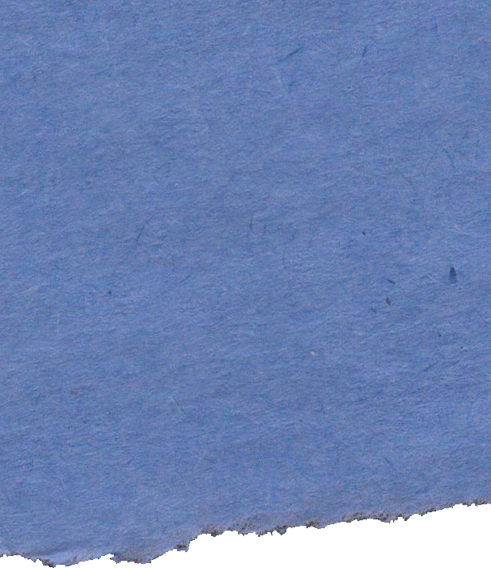
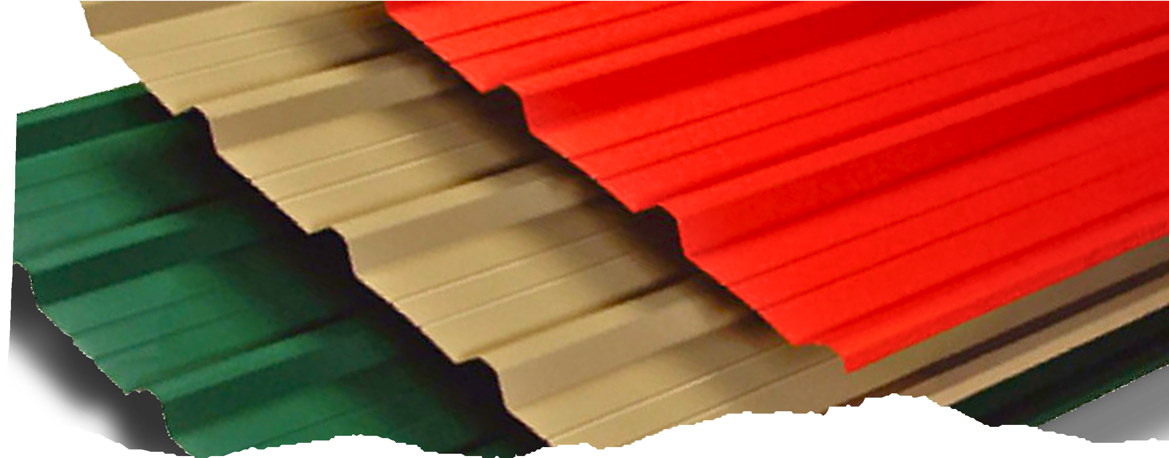

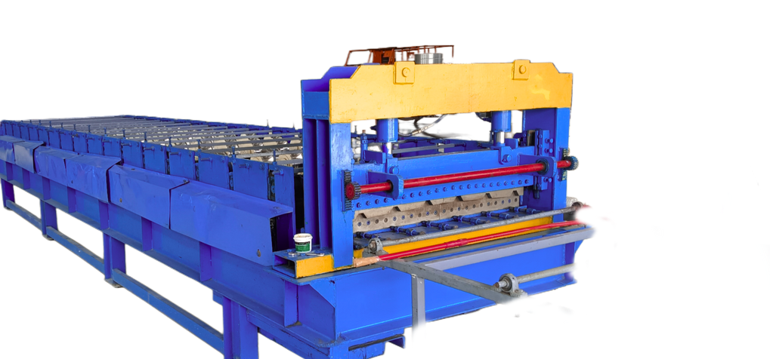
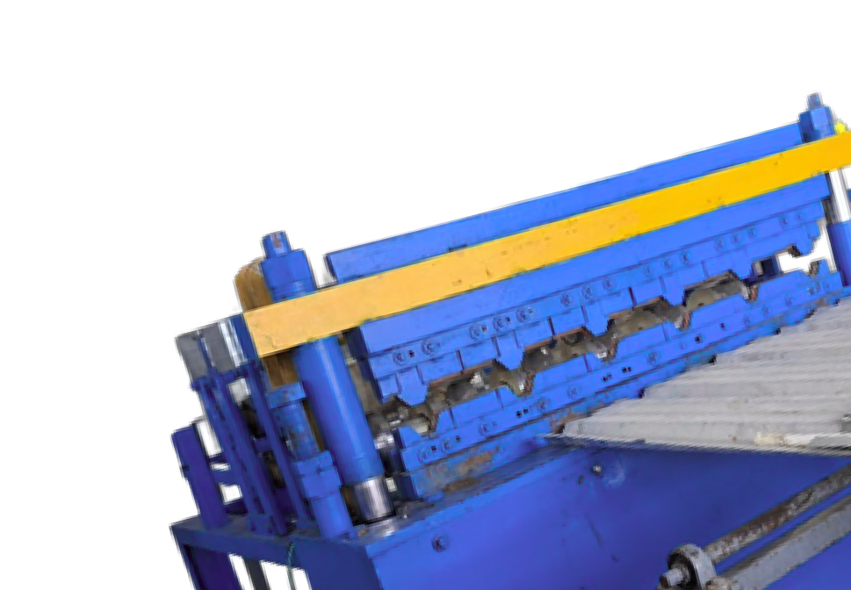
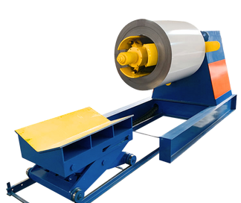
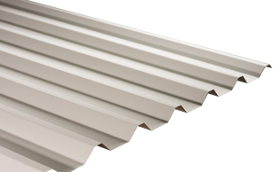
Visit Us
113/11, Block A, SP Industrial

About
our services
RooSfingsP& Metals

RooSfingsP& Metals

Park, Marasandiram, 635121
Krishnagiri, Tamilnadu.

9597999697, 6366815050
@sproofings&metals info@sproofings.com
Our product range includes metal roofing sheets, color-coated sheets, GI sheets, and customized roofing profiles designed to meet diverse project requirements.
Every sheet is manufactured using premium-grade raw materials and conforms to industry standards for thickness, coating, and load- bearing performance.

AVAILABLE COLORS


SP

Roofings S

Metals
Color Coated sheets

www.sproofings.org


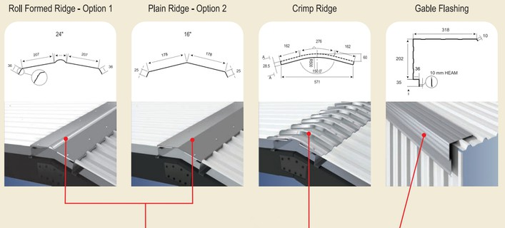
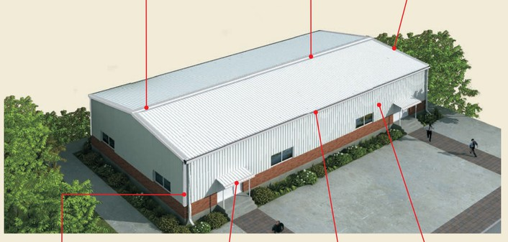
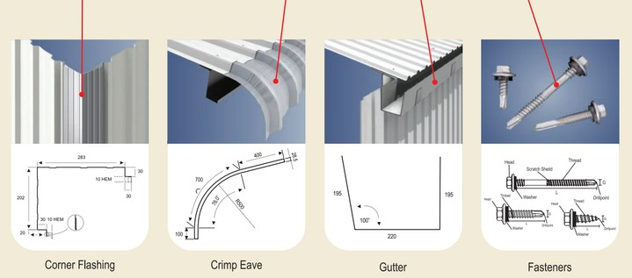

Accessories:

RooSfingsP& Metals

Products S Specifications

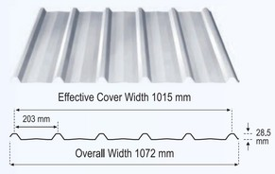
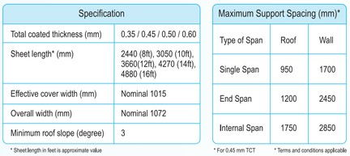
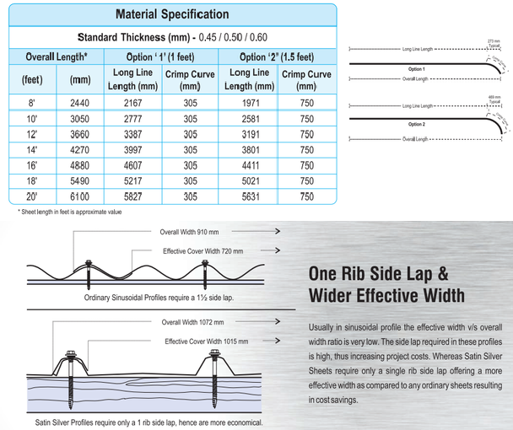
Values Goals

RooSfingsP& Metals

To be a leading roofing sheet manufacturer, recognized for superior quality, innovation, and reliability, delivering long-lasting roofing solutions that protect and perform across industries.
Maintenance Recommenfiation: Clean & Maintain your roof regularly to remove dust & dirt
We are dedicated to environmentally responsible manufacturing practices by minimizing waste, optimizing resource usage, and complying with all environmental regulations. We ensure a safe and healthy workplace by maintaining high safety standards and promoting awareness among our employees.

